Week 1 Unit 1

Introducing SAPUI5

Please perform the exercises below in your app project as shown in the video.

Table of Contents

1 Open SAP Web IDE 2

2 Bootstrap 3

## Preview

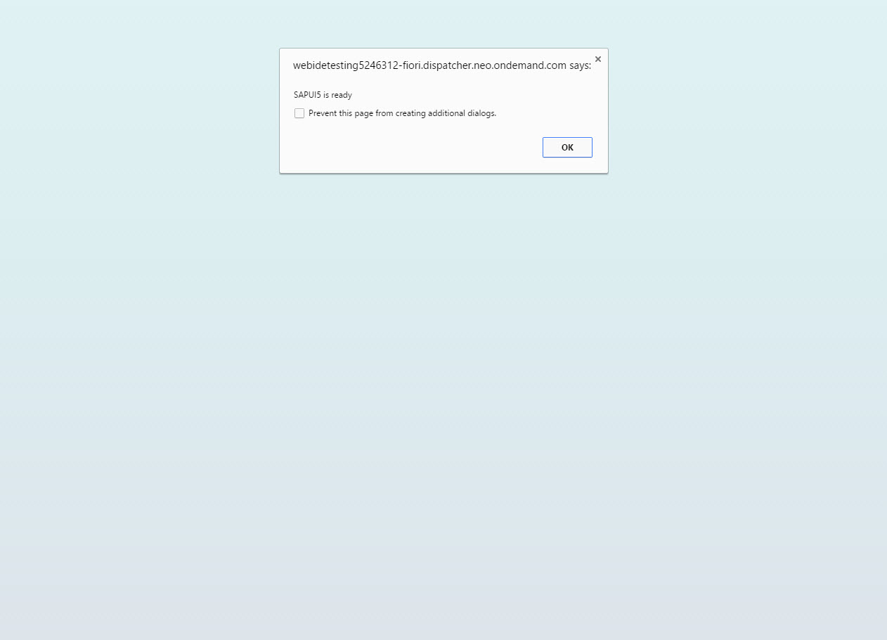

Figure 1 - Preview of the app after doing this unit’s exercises

# Open SAP Web IDE

### Access your development environment (Recap)

As seen in Week 0 Unit 1 of the course, open SAP web IDE to access your development project.

| Explanation | **Screenshot** |
| --- | --- |
| 1. Go to the services page of the SAP HCP Cockpit by opening the following URL and pressing the menu item “Services”:   <https://account.hanatrial.ondemand.com/cockpit> |  |
| 1. In the search field filter for “web” and click on the tile “SAP Web IDE“.   Click on the link “Open SAP Web IDE” to open your development environment. |  |
| 1. Go to the development perspective by clicking on the icon “</>” in the left toolbar. On the left side you will see a folder list with your app projects.   **Note:**  We will use SAP Web IDE for all the exercises in this course, from now on we will assume that you have SAP Web IDE opened in the development perspective to work on your app projects. |  |

# Bootstrap

In this step, we will create a very simple web page and load the SAPUI5 library.

**Note:**Starting this unit, you can verify your exercise coding with the **Validator tool** thatwe have created for specially for this course. It helps you with the exercise tasks by verifying your code. To use the validator, simply add the following code to your HTML page to inject the validator to your app:

**<script src="https://sap.github.io/openSAP-ui5-course/Validator.js"></script>**

Please have a look at **week 0 unit 5 – A Glance at the Coding Exercises** for more information and more detailed instructions on how to set it up.

### webapp/index.html (NEW)

**<!DOCTYPE html>**

**<html>**

**<head>**

**<meta http-equiv="X-UA-Compatible" content="IE=edge"/>**

**<meta charset="UTF-8">**

**<title>openSAP - Developing Web Apps with SAPUI5</title>**

**</head>**

**<body>**

**<p>Hello World</p>**

**</body>**

**</html>**

If you haven’t done so yet in the preparation week of the course, create a project folder and an HTML page. Add a new project folder MyApp by right-clicking on the “Local” entry in the source tree it and selecting “New > Folder”.

Inside this folder create a new folder webapp, which will contain all sources of the app we will create throughout the first weeks of this course. Now create a new root HTML file called index.html in your app folder with the contents of the listing above.

Your workspace should now look like this:

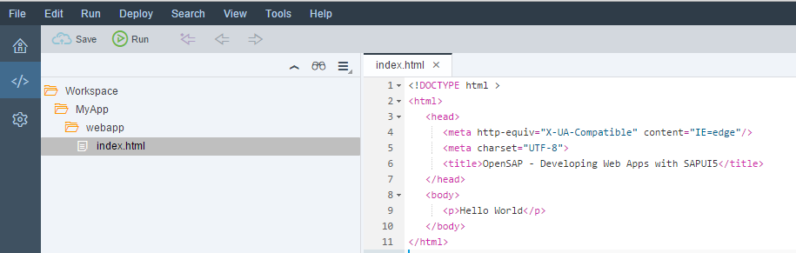

Figure 2 - Workspace for the test page

Save your changes and press the  button in the header toolbar. A new tab will open with the preview of your app. In all the following exercises you can test your code like this.

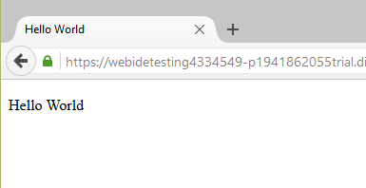

Figure 3 - Preview of the test page

### webapp/index.html

|  |
| --- |
| <!DOCTYPE html>  <html>  <head>  <meta http-equiv="X-UA-Compatible" content="IE=edge">  <meta charset="utf-8">  <title>openSAP - Developing Web Apps with SAPUI5</title>  **<script**  **id="sap-ui-bootstrap"**  **src="https://sapui5.hana.ondemand.com/resources/sap-ui-core.js"**  **data-sap-ui-theme="sap_bluecrystal"**  **data-sap-ui-libs="sap.m"**  **data-sap-ui-compatVersion="edge"**  **data-sap-ui-preload="async">**  **</script>**  **<script>**  **sap.ui.getCore().attachInit(function () {**  **alert("SAPUI5 is ready");**  **});**  **</script>**  </head>  **<body class="sapUiBody" id="content">**  **</body>**  </html> |

Before we can do anything with SAPUI5, we need to load and initialize it. This process of loading and initializing SAPUI5 is called bootstrapping. Once this bootstrapping is finished, we simply display an alert.

In the code above, we load the SAPUI5 framework from the Content Delivery Network (CDN) at <https://sapui5.hana.ondemand.com/resources/sap-ui-core.js>.

**Note:**

You can use this reference to the latest stable version of SAPUI5 for the exercises or for testing purposes, but never do this for productive use. In an actual app, when using our content delivery network, you always have to specify an SAPUI5 version explicitly. Have a look at the documentation for more details. The URL will then look like this: https://sapui5.hana.ondemand.com/1.34.10/resources/sap-ui-core.js

We initialize the UI5 core with the following configuration options:

* The src attribute of the first <script> tag tells the browser where to find the SAPUI5 core library – it initializes the SAPUI5 runtime and loads additional resources, such as the libraries specified in the data-sap-ui-libs attribute.
* The SAPUI5 controls support different themes, we choose sap_bluecrystal as our default theme.
* We specify the required UI library sap.m containing the UI controls we need for this tutorial.
* To make use of the most recent functionality of SAPUI5 we define the compatibility version as edge.
* We configure the process of “bootstrapping” to run asynchronously.  
  This means that the SAPUI5 resources can be loaded simultaneously in the background for performance reasons.

When all resources and libraries are loaded, the SAPUI5 runtime fires the global init event to signal that the library is ready. When loading the libraries asynchronously, you have to listen for this event in order to trigger your application logic only after the required resources are loaded.

In the example above, we get a reference to the SAPUI5 core by calling sap.ui.getCore() and register an anonymous callback function for the init event by calling attachInit(…) on the core. In SAPUI5 these kinds of callback functions are often referred to as event handlers, event listener functions, or simply listeners. The core is a singleton and can be accessed from anywhere in the code.

Our anonymous callback function is executed when the bootstrap of SAPUI5 is finished and displays a native JavaScript alert.

**Note:**You can remove the “Hello World” text from the body now, it will not be used in the next units.

### Related Information

[Bootstrapping: Loading and Initializing](http://sapui5.hana.ondemand.com:8080/demokit/docs/guide/a04b0d10fb494d1cb722b9e341b584ba.html)

[Preload Variant for Bootstrapping](http://sapui5.hana.ondemand.com:8080/demokit/docs/guide/91f1e3626f4d1014b6dd926db0e91070.html)

[Compatibility Version Information](http://sapui5.hana.ondemand.com:8080/demokit/docs/guide/9feb96da02c2429bb1afcf6534d77c79.html)

[Variant for Bootstrapping from Content Delivery Network](http://sapui5.hana.ondemand.com:8080/demokit/docs/guide/2d3eb2f322ea4a82983c1c62a33ec4ae.html)

**Coding Samples**

Any software coding or code lines/strings (“Code”) provided in this documentation are only examples and are not intended for use in a productive system environment. The Code is only intended to better explain and visualize the syntax and phrasing rules for certain SAP coding. SAP does not warrant the correctness or completeness of the Code provided herein and SAP shall not be liable for errors or damages cause by use of the Code, except where such damages were caused by SAP with intent or with gross negligence.